Ex.no:7b | DATA VISUALIZATION USING TABLEAU-  FOOD WASTE PREDICTION DATASET

Aim

To connect, analyze, visualize, and create an interactive dashboard using Tableau with the Housing Price dataset to analyze housing values, ocean-proximity categories, housing median age, property value contribution, house value percentage, and factors influencing housing prices.

Software Requirements

• Tableau Desktop / Tableau Public
• Microsoft Excel
• CSV Dataset
• Windows Operating System

Theory

Tableau is a powerful Business Intelligence (BI) and Data Visualization tool used to create interactive dashboards, worksheets, charts, and reports.

The Housing Price dataset contains information related to housing characteristics and property values. It includes geographical information, housing age, number of rooms, bedrooms, population, households, median income, median house value, and ocean proximity.

The dataset includes:
- Longitude
- Latitude
- Housing Median Age
- Total Rooms
- Total Bedrooms
- Population
- Households
- Median Income
- Median House Value
- Ocean Proximity

Tableau allows users to analyze housing values, compare properties based on ocean proximity, study housing-price trends, calculate percentage contributions, and interactively explore the data using filters and parameters.

Tableau Architecture
Housing Price Dataset

↓

Data Connection

↓

Worksheets

↓

Visualizations

↓

Dashboard

↓

Story

Learning Outcomes

After completing this experiment, students will be able to:

✓ Connect the Housing Price dataset to Tableau

✓ Create worksheets using dimensions and measures

✓ Generate different charts and visualizations

✓ Analyze housing price variation with housing median age

✓ Create calculated fields

✓ Apply filters and parameters

✓ Build interactive dashboards

✓ Create stories for housing price analysis

✓ Interpret patterns from housing data

✓ Create stories for house sales

Sample Dataset

Housing Price Dataset

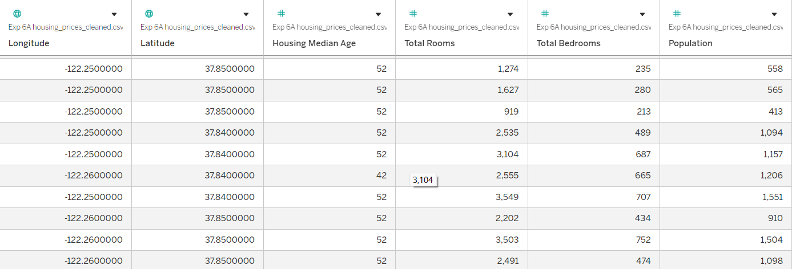

Algorithm 1 – Connecting Data Source

Step 1
Open Tableau Desktop.

Step 2
Select Connect.

Step 3
Choose Text File because the dataset is in CSV format.

Step 4
Browse and select the Exp 6A housing_prices_cleaned.csv file.

Step 5
Open the dataset.

Step 6
Verify the imported fields such as:
- Longitude
- Latitude
- Housing Median Age
- Total Rooms
- Total Bedrooms
- Population
- Households
- Median Income
- Median House Value
- Ocean Proximity

Procedure

Tableau

↓

Connect

↓

Text File

↓

Housing Price Dataset

↓

Open

↓

Verify Data

Output

Housing Price Dataset loaded into Tableau successfully.

Algorithm 2 – Bar Chart Creation

Step 1

Open a new worksheet.

Step 2

Drag Ocean Proximity → Rows.

Step 3

Drag Median House Value → Columns.

Step 4

Set the aggregation to AVG(Median House Value).

Step 5

Select Bar Chart from the visualization options.

Step 6

Enable Show Mark Labels.

Step 7

Add the title:

Housing Value by Ocean Proximity

Output

Worksheet created successfully.

Interpretation

The bar chart compares the average median house value across different ocean-proximity categories. It helps identify locations with relatively higher and lower average housing values.

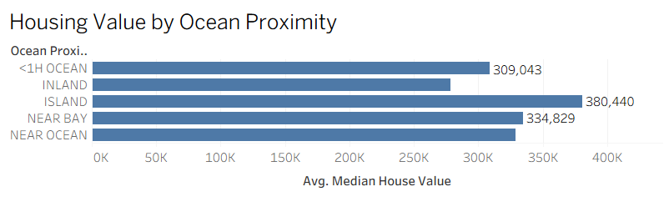

Algorithm 3 – Pie Chart Creation

Objective

To analyze the contribution of different ocean-proximity categories to the total median house value.

Step 1

Open a new worksheet.

Step 2

Select Pie Chart from Show Me.

Step 3

Drag Ocean Proximity → Color.

Step 4

Drag Median House Value → Angle.

Step 5

Drag Ocean Proximity → Label.

Step 6

Drag Median House Value → Label.

Step 7

Enable the required labels.

Output Visualization

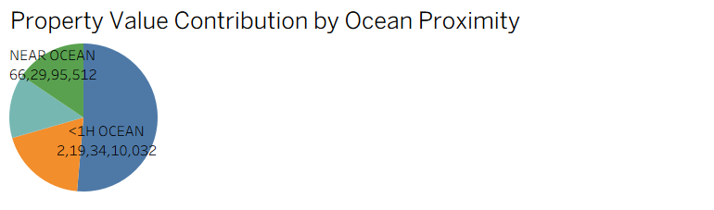

Interpretation

The pie chart shows the contribution of different ocean-proximity categories to the total recorded median house value. It provides a visual comparison of the relative property-value contribution of each category

Algorithm 4 – Line Chart Creation

Objective

To analyze the variation in average median house value across different housing median ages.

Step 1

Drag Housing Median Age → Columns.

Step 2

Drag Median House Value → Rows.

Step 3

Set the aggregation to AVG(Median House Value).

Step 4

Select Line Chart.

Step 5

Analyze the housing-price variation across different housing median ages.

Output Visualization

Housing Price Trend

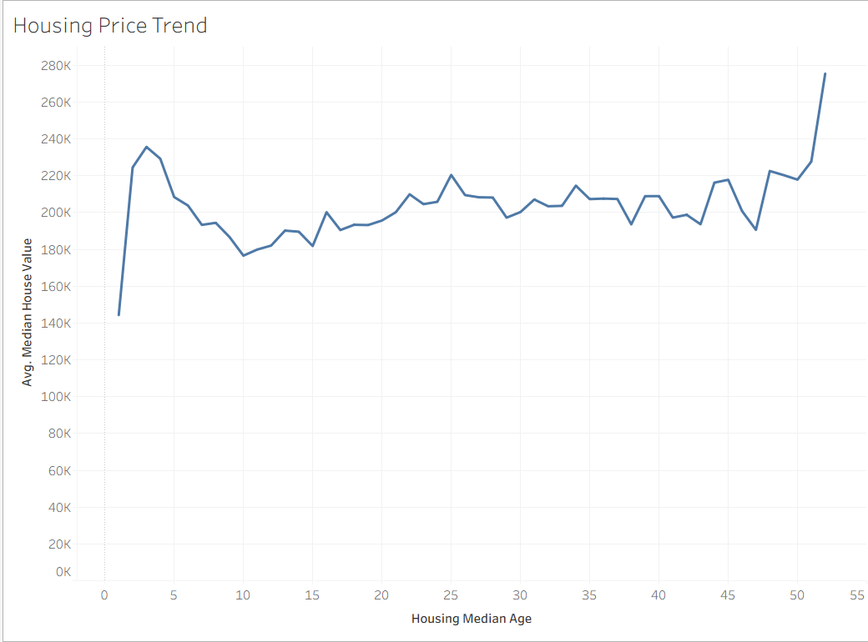

Interpretation

The line chart shows how the average median house value varies across different housing median ages. It helps identify increases, decreases, peaks, and lower-value ranges in housing prices.

Algorithm 5 – Creating Calculated Field

Objective

To calculate the percentage contribution of each ocean-proximity category to the total median house value.

Step 1

Analysis → Create Calculated Field

Step 2

Enter the field name:

Step 3

Enter the formula:

SUM([Median House Value]) / TOTAL(SUM([Median House Value]))

Step 4

Click OK.

Output Visualization

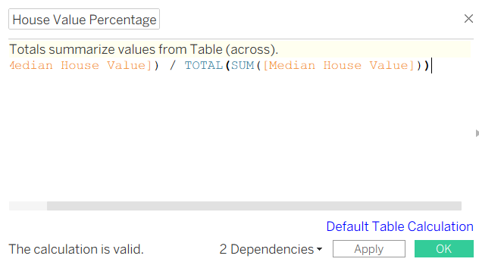

Interpretation

The calculated field determines the percentage contribution of each ocean-proximity category to the overall median house value. This allows the relative contribution of different housing locations to be compared easily.

Algorithm 6 – House Value Percentage Visualization

Objective

To visualize the percentage contribution of each ocean-proximity category.

Step 1

Drag Ocean Proximity → Rows.

Step 2

Drag House Value Percentage → Columns.

Step 3

Select Bar Chart.

Step 4

Format the field as Percentage.

Step 5

Enable mark labels.

Step 6:

Add the title:

House Value Percentage by Ocean Proximity

Output

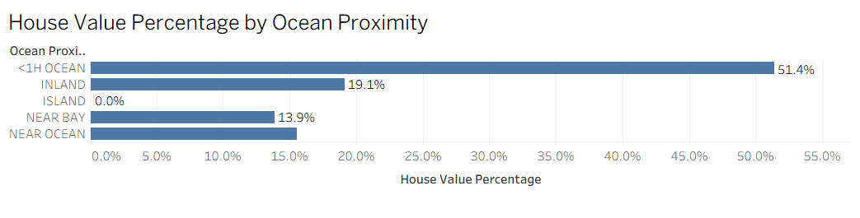

Interpretation

The percentage chart makes it easier to compare the relative contribution of different ocean-proximity categories. The values are represented as percentages of the total.

Algorithm 7 – Applying Filters

Objective

To analyze housing values for a specific ocean-proximity category.

Step 1

Drag Ocean Proximity → Filters shelf.

Step 2

Select the required categories.

Step 3

Click Show Filter.

Step 4

Select a category such as:

Step 5

Observe the updated visualization.

Example

Filter: Ocean Proximity = INLAND

Output

The visualization displays only the housing records belonging to the selected ocean-proximity category

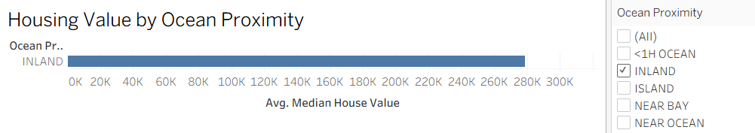

Interpretation

The Ocean Proximity filter allows users to focus on a particular location category and perform detailed housing-price analysis.

Algorithm 8 – Creating Parameter

Objective

To dynamically analyze housing records based on a user-defined minimum house value.

Step 1

Select:

Create Parameter

Step 2

Specify the parameter name:

Minimum House Value

Step 3

Set the data type as:

Integer

Step 4

Set the required minimum value.

Step 5

Create a calculated field using the parameter.

Formula

[Median House Value] >= [Minimum House Value]

Example

Minimum House Value = 200,000

Step 6

Place Minimum Value Filter on the Filters shelf.

Step 7

Select True.

Output:

The visualization displays housing records satisfying the selected minimum house-value threshold

Interpretation

The parameter allows users to dynamically identify housing records based on a selected minimum property-value threshold.

Algorithm 9 – Dashboard Creation

Objective

To create an interactive Housing Price Analysis Dashboard.

Step 1

Create the required worksheets

Step 2

Dashboard → New Dashboard

Step 3

Drag the required worksheets into the dashboard.

Step 4

Arrange the charts clearly.

Step 5

Add the interactive controls:
- Ocean Proximity
- Minimum House Value

Step 6

Add the Minimum House Value parameter.

Step 7

Add appropriate titles and labels.

Dashboard Analysis

Housing Value by Ocean Proximity

Average median house value across ocean-proximity categories.

Property Value Contribution

Shows the relative contribution of each ocean-proximity category.

Housing Price Trend

Shows variation in average median house value across housing median ages.

House Value Percentage

Shows percentage contribution of each category to the total.

Interpretation

The dashboard provides a consolidated view of housing values, ocean-proximity analysis, housing-age trends, percentage contribution, and interactive filtering. The filter and parameter allow users to explore different housing conditions dynamically.

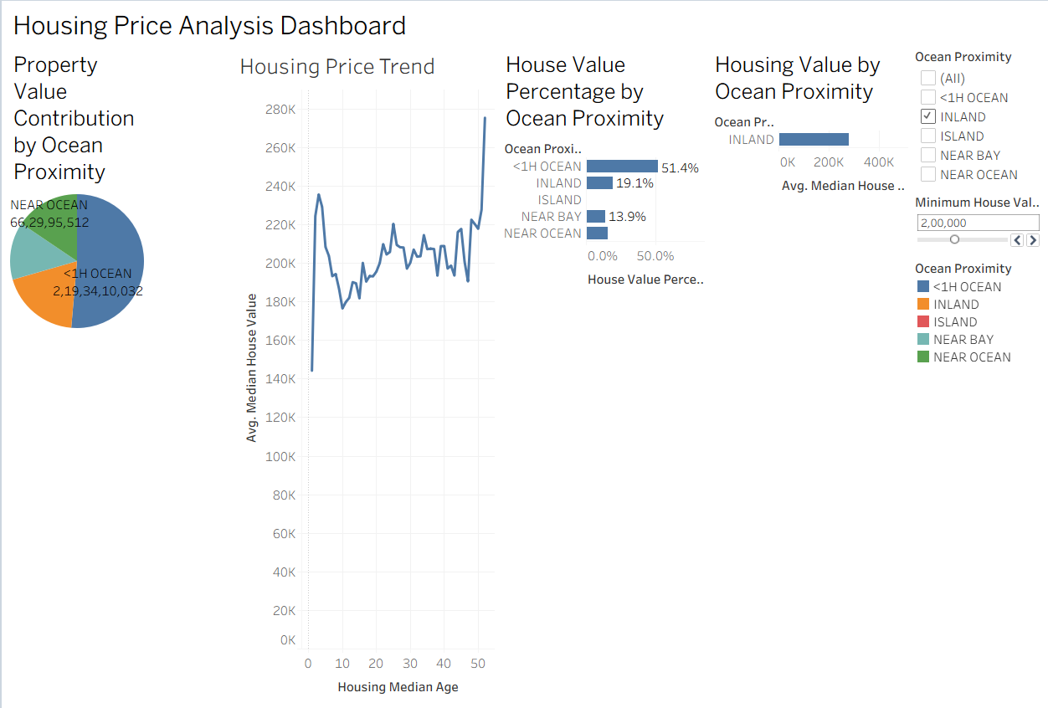

Algorithm 10 – Story Creation

Objective

To present the housing price analysis through a sequence of visual insights using Tableau Story.

Step 1

Create the required worksheets.

Step 2

Create the Housing Price Analysis Dashboard.

Step 3

Select Story → New Story.

Step 4

Add the dashboard and required worksheets as story points.

Step 5

Arrange the story points in a logical sequence.

Step 6

Add captions explaining the findings.

Example Story

Story Point 1

Overall Housing Price Analysis

The dashboard provides an overall analysis of housing prices based on ocean proximity, housing median age, and property value percentage. Interactive filters and parameters allow users to explore different housing categories.

Story Point 2

Ocean Proximity Analysis

The visualization compares the average median house value across different ocean-proximity categories. It helps identify differences between inland, coastal, near-ocean, and island properties.

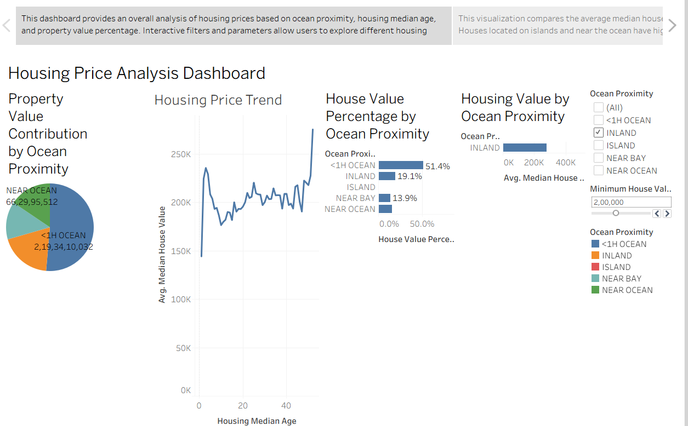

Story Point 3

High-Value Housing Analysis

Using the Minimum House Value parameter, the visualization analyzes housing records based on a selected minimum property-value threshold. This helps identify higher-value housing locations.

Story Point 4

Housing Price Trend Analysis

The line chart shows the relationship between housing median age and average median house value. It helps identify how housing prices vary across different housing ages.

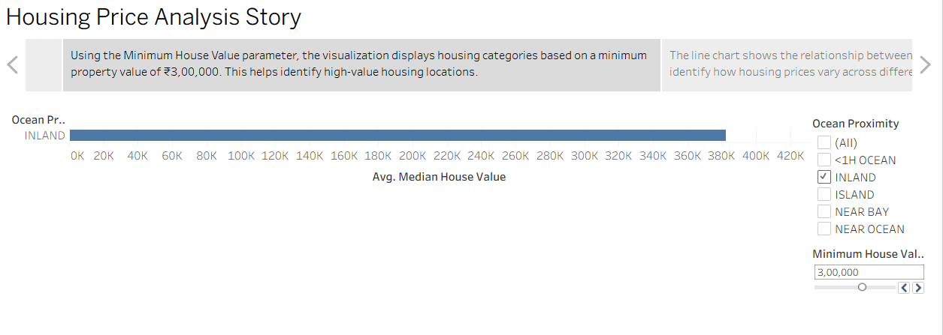

Applications

Real Estate Analysis

Analysis of housing values across different locations and ocean-proximity categories.

Property Investment

Identification of relatively higher-value and lower-value housing categories.

Location-Based Analysis

Analysis of how proximity to the ocean is associated with housing values.

Housing Market Analysis

Comparison of average property values and percentage contributions across different categories.

Trend Analysis

Analysis of changes in average median house value across different housing median ages.

Business Intelligence

Interactive visualization and dashboard-based housing-price analysis.

Decision Making

Identification of high-value housing categories using filters and parameters.

Data Analytics

Interactive exploration and interpretation of housing-price patterns.

Result

